**Securing AWS resources**

**By**

**Israel Nolazco**

AWS is much more than a cloud service provider. AWS is an environment on its and its features go beyond simply providing cloud services. The customer could in fact track and alter so many different aspects of their services. This could range between their method of payment, trafficking traffic, creating users and groups and so much. In this document we are going to explore AWS security resources and setting. We are going to explore three major security resources available to us by AWS. First, we are going to explore the creation of groups, user and assigned dedicated policies to their role. Then, we are going to create an S3 bucket and verify the bucket’s security policy. Finally, we are going to explore the security group setting for a EC2 instance; by modifying the inbound traffic to our Linux VM1.

1. Users and Groups.

In this section we are going to create two users and two groups. In this trial one group is going to represent the Tech group and the other the Finance group. Because of their unique names, the tech group should not have access of the billing information since it does not fall within their purview. To make this modification we must first allow billing to view by other users.

Then we are going to create two users.

Then we are going to create our to groups. To start us off we are going to create the Tech group. This group should only have access to the EC2 and S3 buckets. Being a tech group they should have access to the tech stuff.

User1 is going to be assigned to this group.

The following group being created is the Finance group. This group will have access to the S3 bucket. The group should be allowed to upload their files and work freely; however, not all of the files should be accessible. This point is going to be further explore afterwards. For the mean time the Finance group will have access to the billing section of our AWS account as seen below.

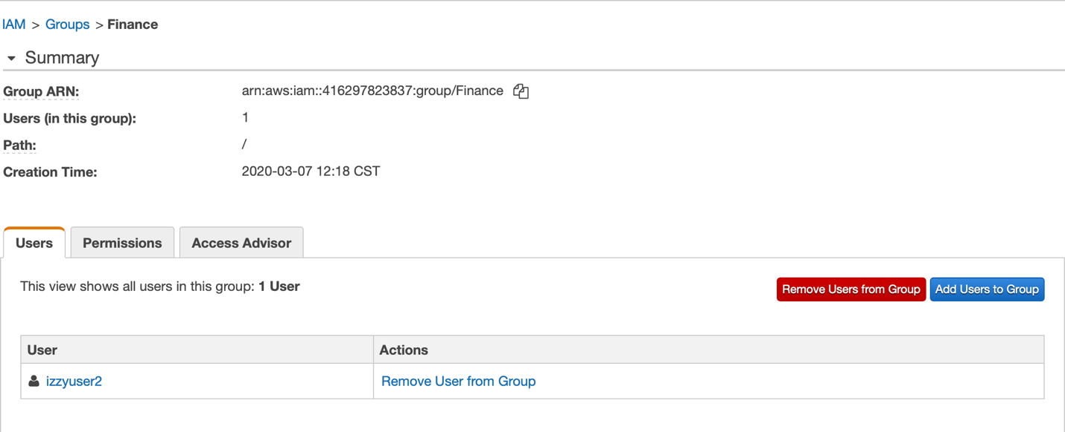

Now that the groups, users and access have been provided, the following step is to verify the truth behind the theory by logging as each newly created user.

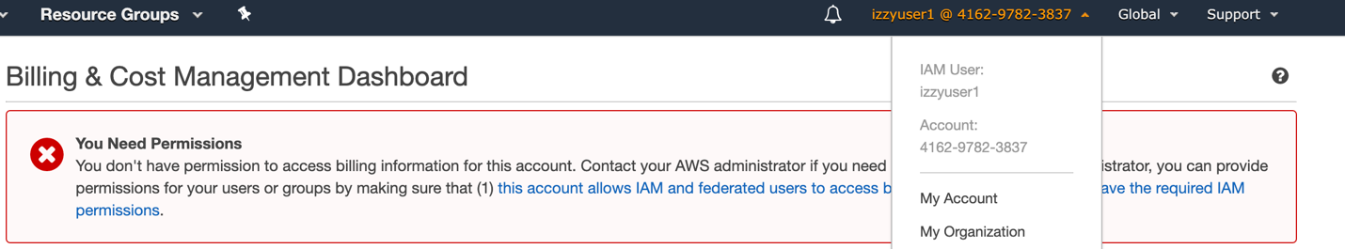

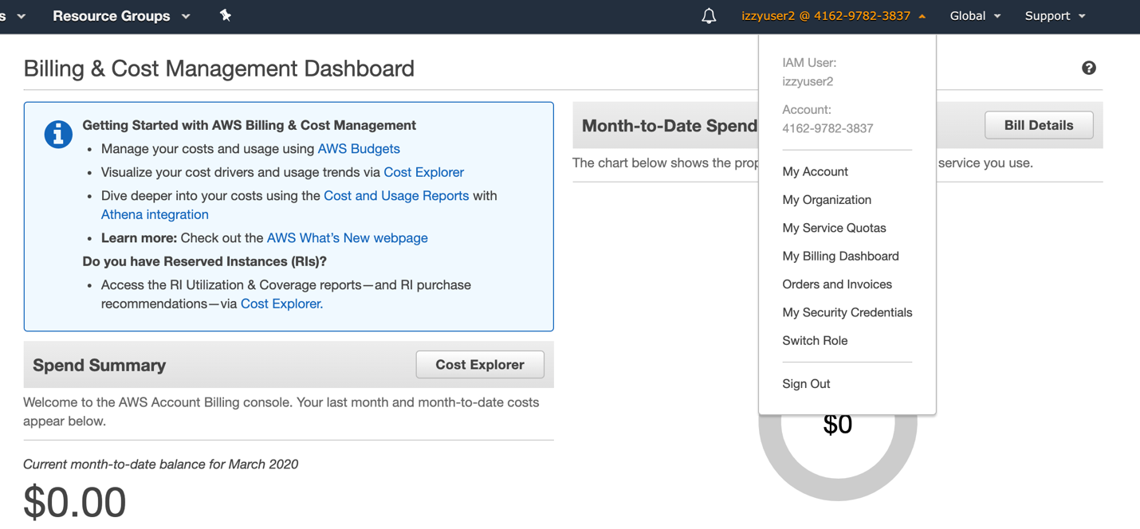

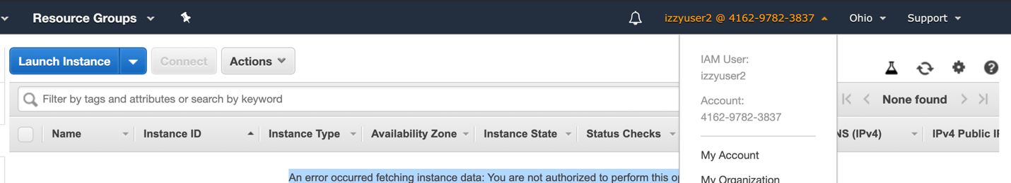

As seen in our images above, the User1 cannot access the billing information whilst the User2 can and User2 cannot create Instances

1. S3 Bucket Policies

I this step we are going to create an S3 bucket and then set up unique policies. These policies will then only allow certain members/groups to access certain buckets.

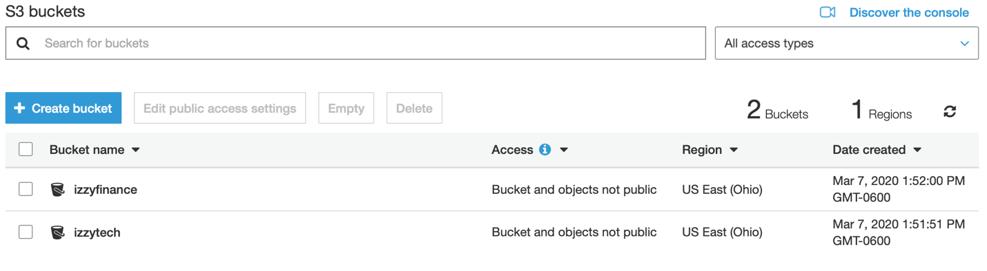

The image above shows two buckets created for the Finance group and one for the Tech group. We are going to first modify the policy for the Finance S3 bucket.

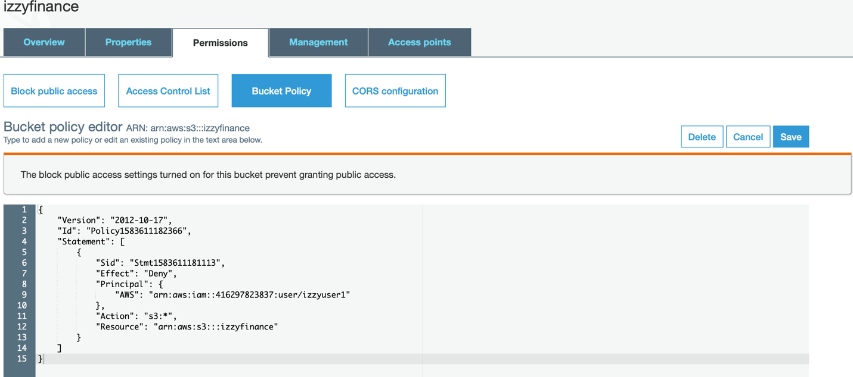

As seen in the image above. The few lines of code deny all access to the User1. AWS special rules set up for read only, upload only and much more. However, for now we are going to deny all access to User1. Now let’s test this out.

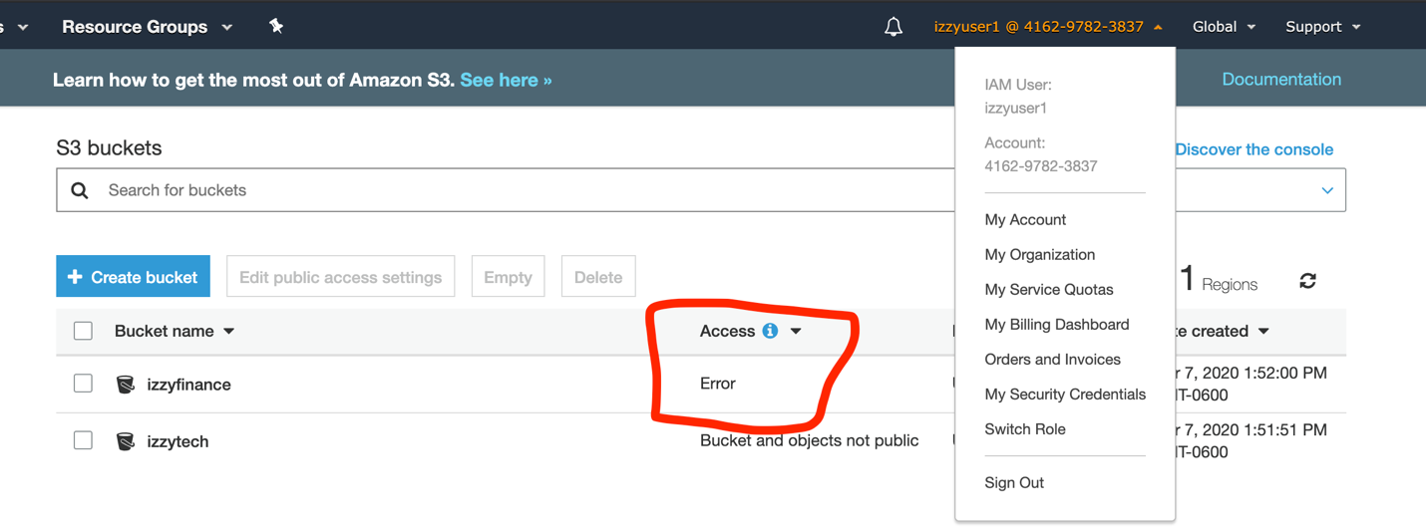

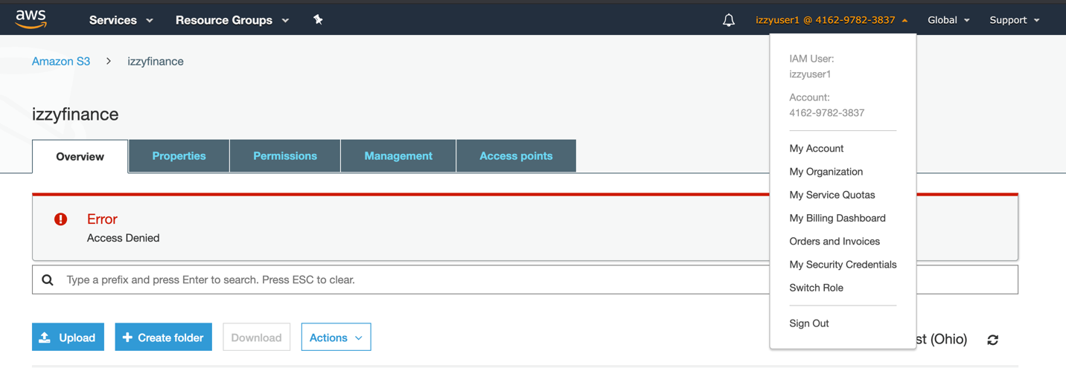

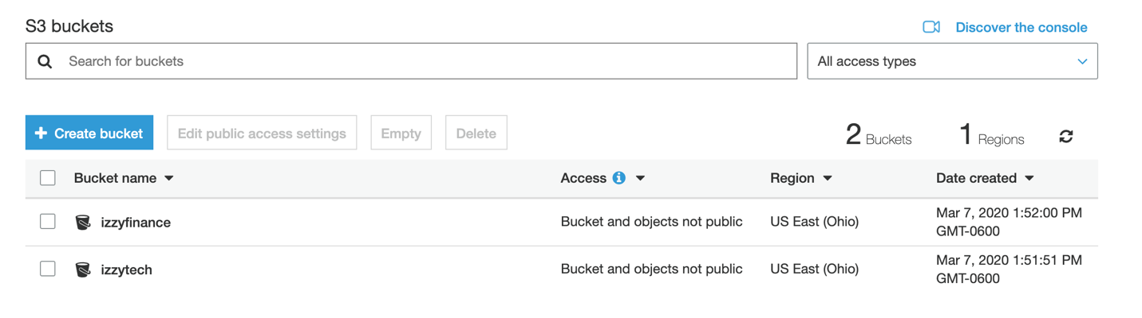

As seen in the images above. User1 has an error before and after attempting to access the bucket. Compare that to User2 that has no error whatsoever.

1. Modify the EC2 security group settings

In this section we are going to explore the EC2 security groups. In the past we have been able to use SSH clients to remotely log into our VM machine. However, in an enterprise there are only certain connections, IPs and firewall setting appropriate for the use of these VM machines. For example: we are going to going to use the following settings.

HTTP Port 80, TCP Port 8080, ICMP port, SSH port 22

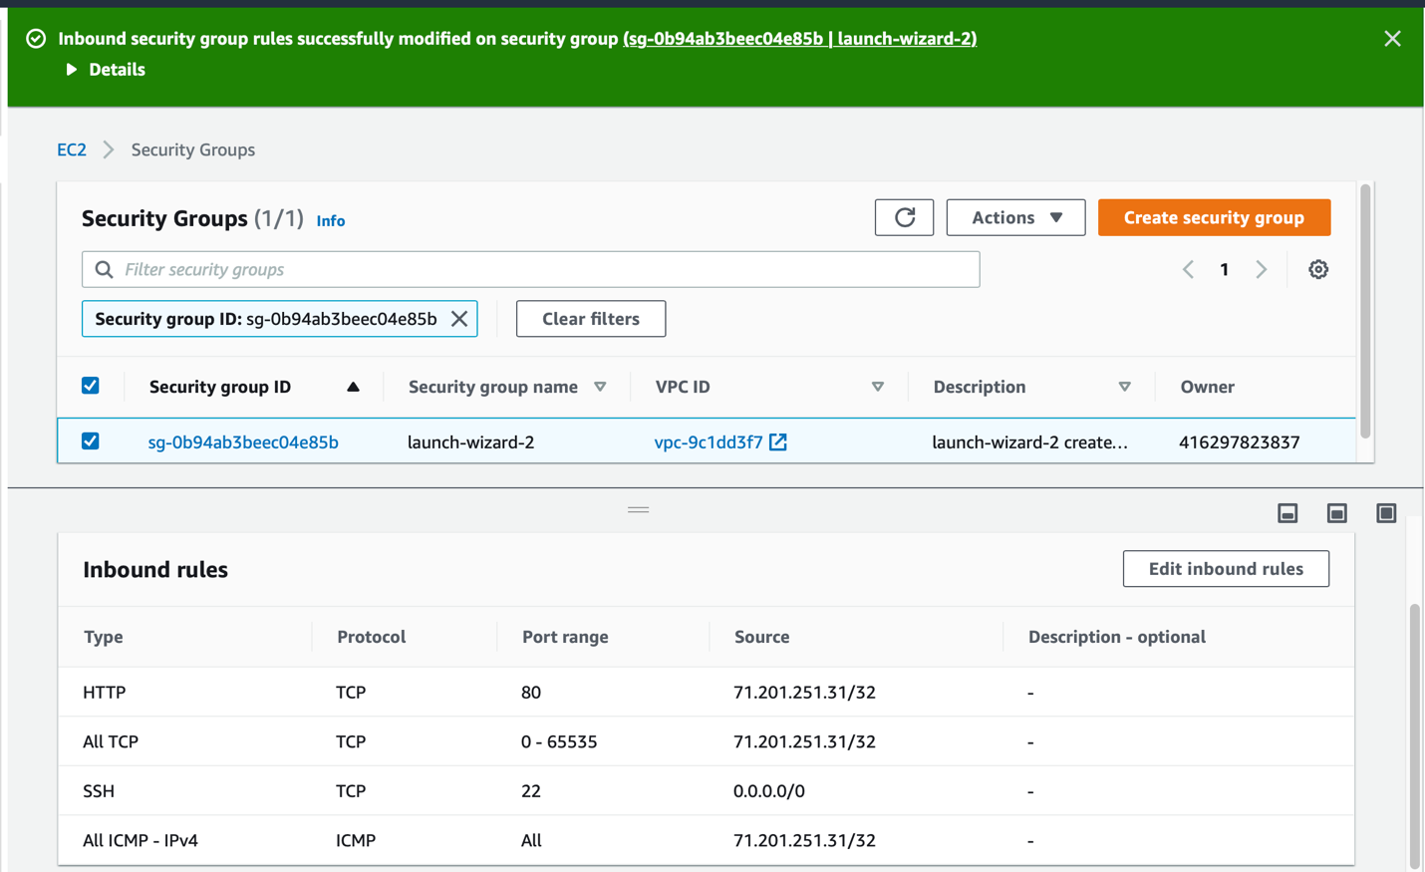

Make a notice of the source. These addresses are specific to my internet connection, thus allowing and only me to log in. In a enterprise level the setting would look different given that there could tens and if not hundreds of different IPs. Alternatively, companies have now relied on VPNs to mask their employees IP and make it seem like it is coming from one source. However, this is a different topic on its own.

Let us first try these setting and see if we can still connect to our VM machine through SSH and ping our VM machine, but first let us start our instance.

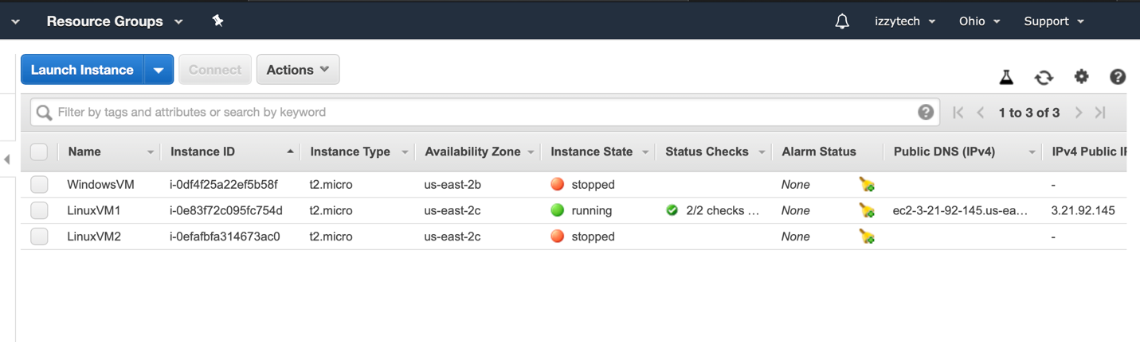

Having our VM machine running and our noting down the public IP. Let us try ping the machine from our terminal.

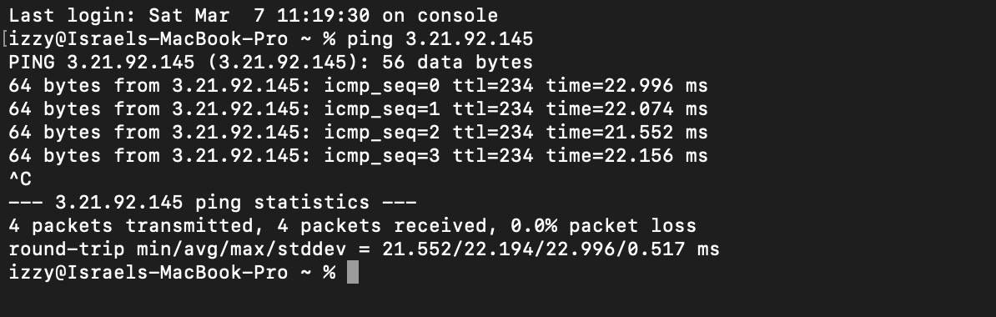

Now to connect remotely through SSH client.

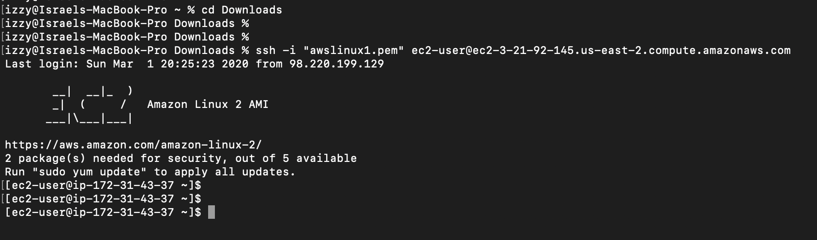

Now, what would happen if we remove everything?

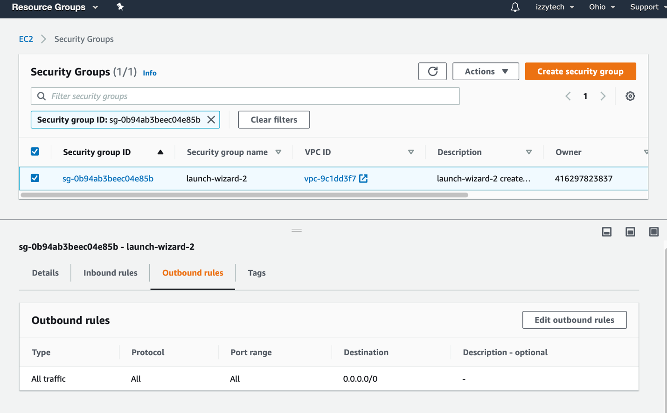

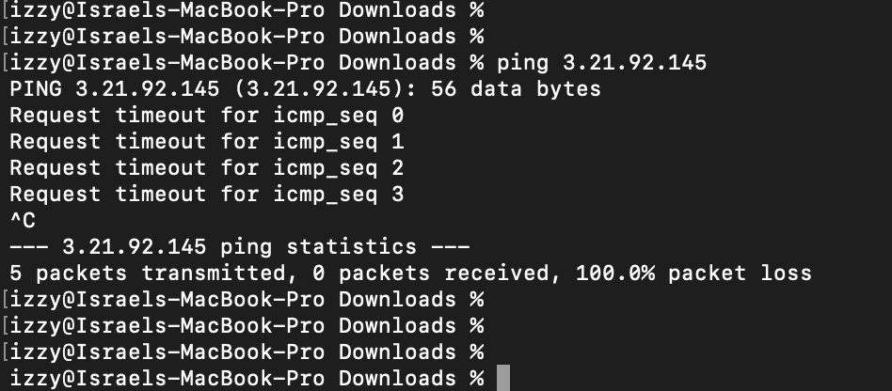



As seen in the image above there our Ping times out and so does our attempt to connect through SSH. In short AWS provides a plethora of setting, each tailor for a very unique and specific purpose.